Steps to Configure Jenkins SSH Build Agent Nodes

Step 1: Log in to Jenkins
- Access the Jenkins UI from the browser.
- Log in using the admin credentials.
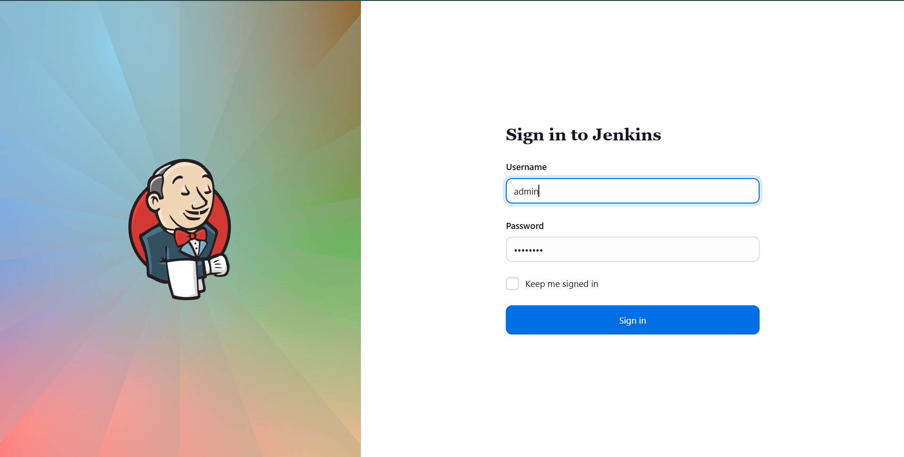

Step 2: Install Required SSH Plugins
- Navigate to Manage Jenkins → Plugins → Available plugins
- Search for SSH
- Install the following plugins:
  - SSH
  - SSH Credentials
  - SSH Build Agents
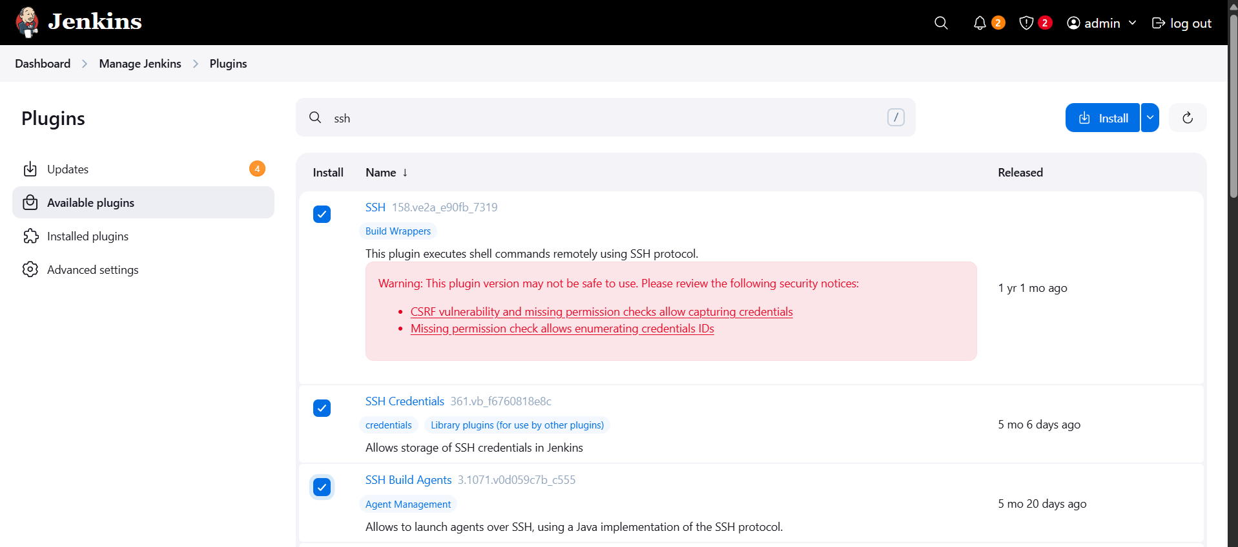
- After installation, perform a Safe Restart of Jenkins from Manage Jenkins.
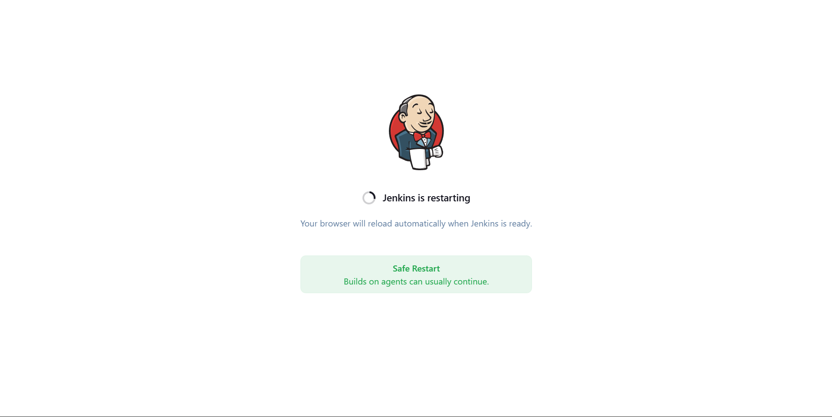

Step 3: Create SSH Credentials for App Servers
- Go to Manage Jenkins → Credentials → System → Global credentials
- Add credentials using Username with password:
  - tony (for stapp01)
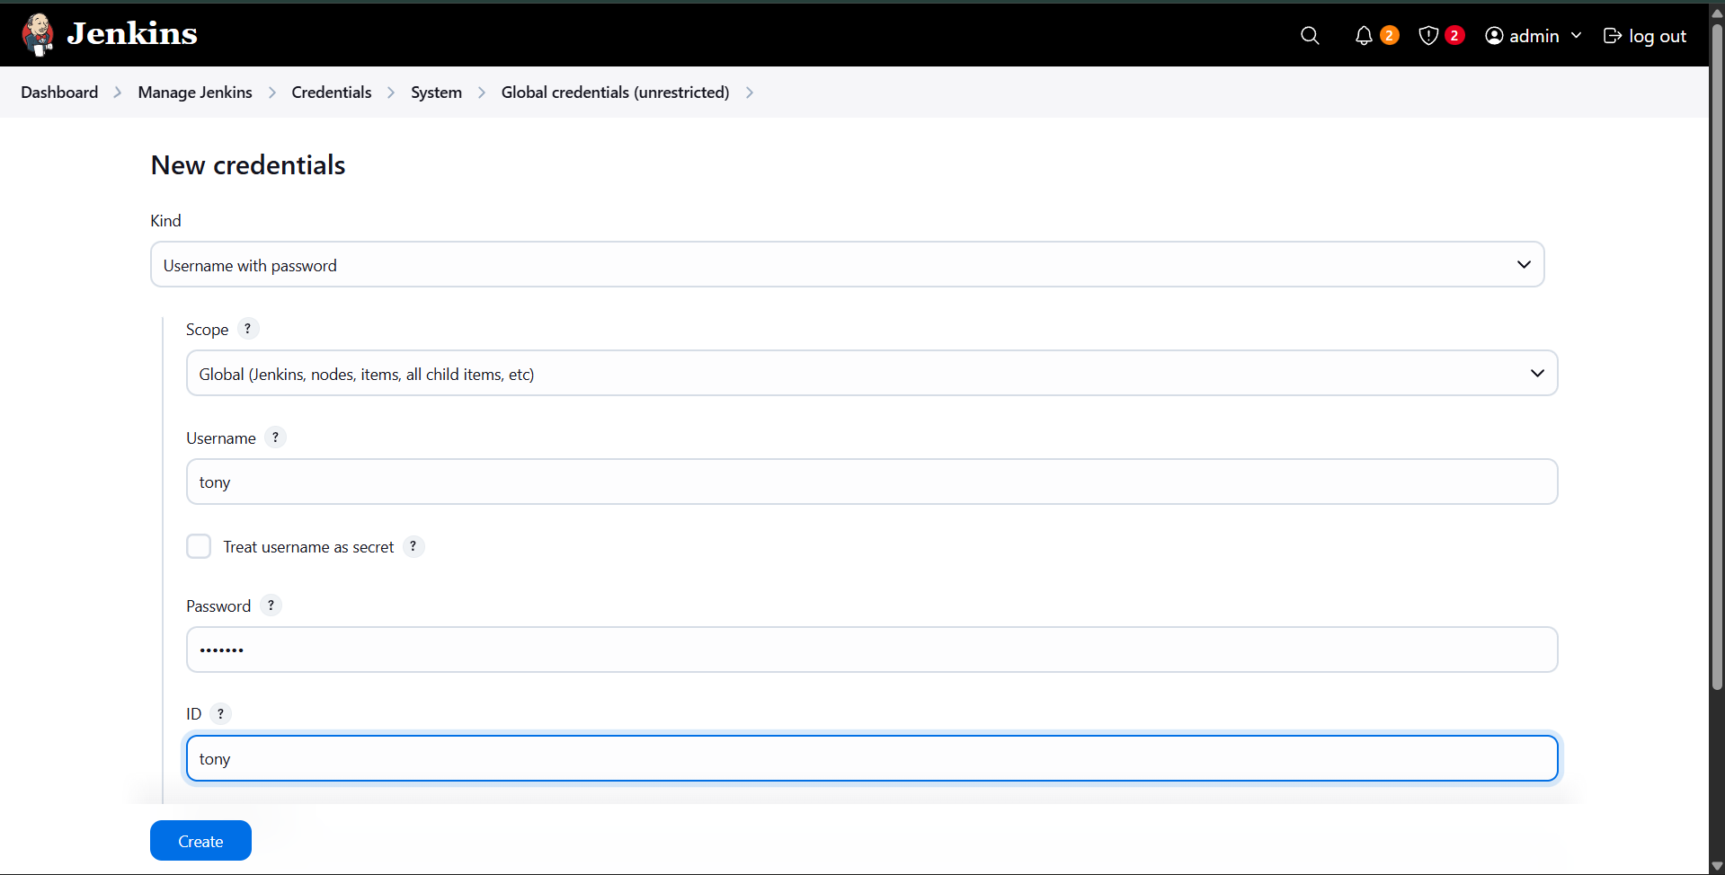
  - steve (for stapp02)
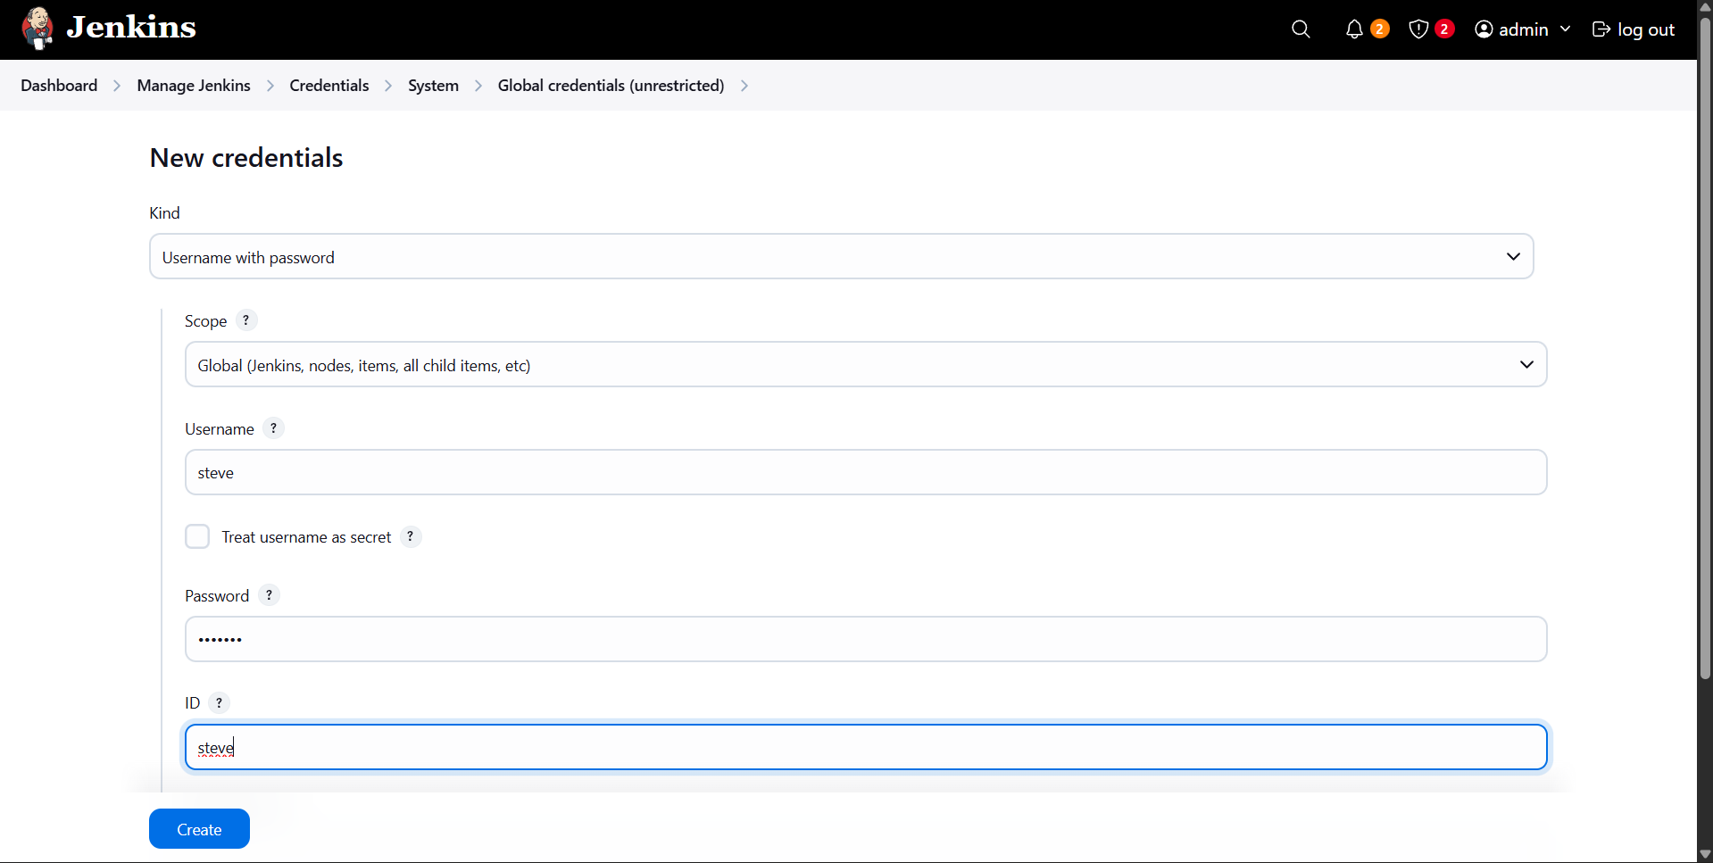
  - banner (for stapp03)
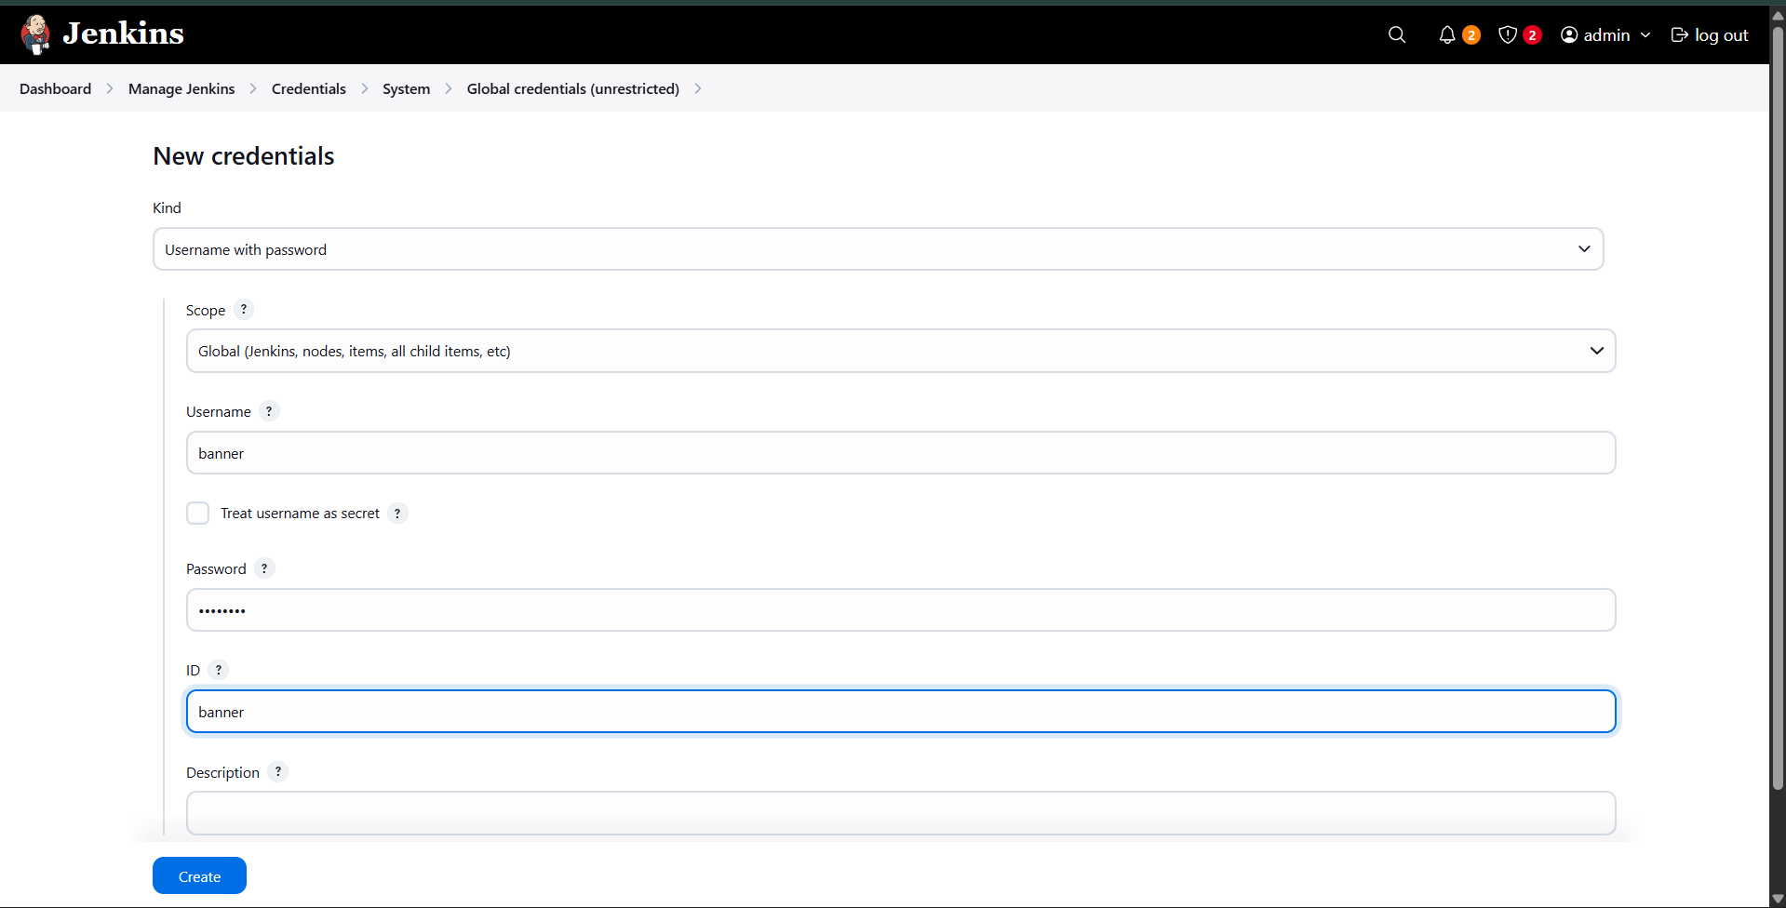
- Set the ID same as the username for easy identification.
- Save all credentials.

Step 4: Prepare Application Servers
- SSH into each application server from the jumphost:
  - stapp01 as user tony
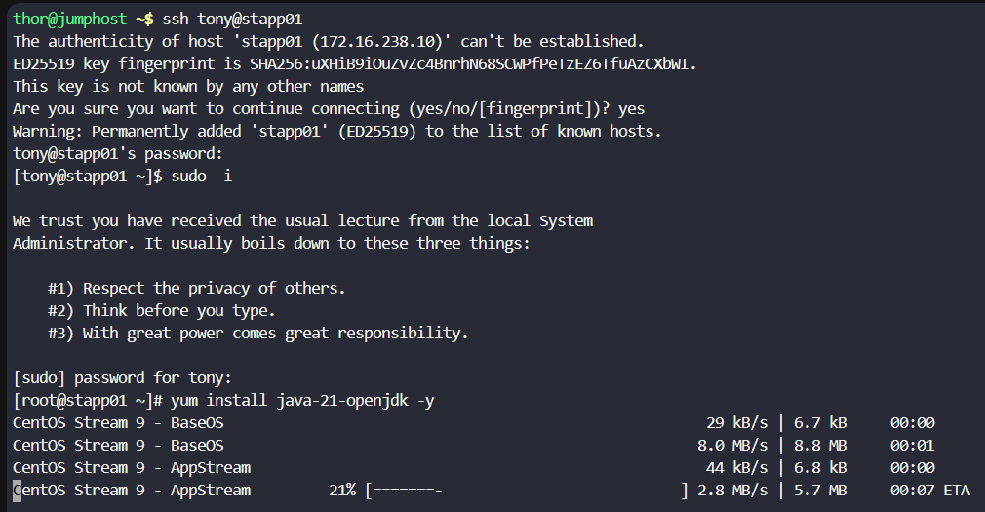
  - stapp02 as user steve
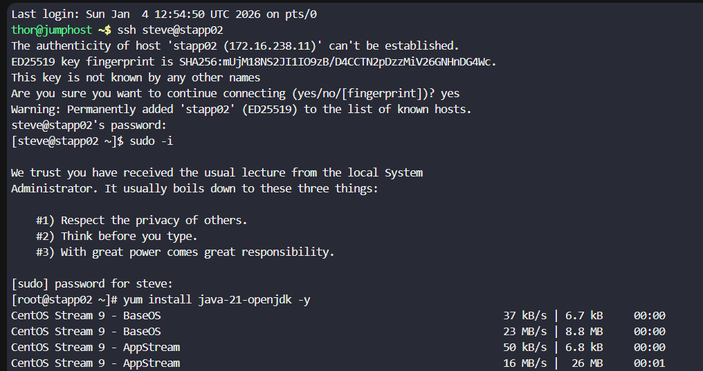
  - stapp03 as user banner
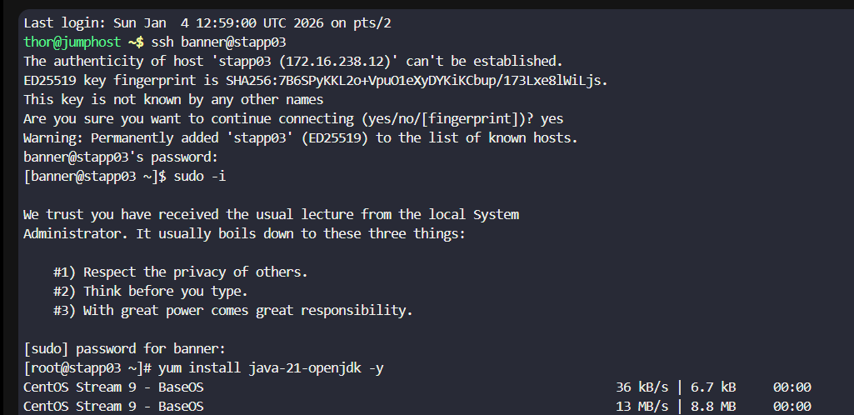
- Switch to root user.
- Install Java on all servers:
- yum install java-21-openjdk -y
- Repeat the same process on all three servers.

Step 5: Create Jenkins Node – App_server_1
- Navigate to Manage Jenkins → Nodes → New Node
- Node name: App_server_1
- Type: Permanent Agent
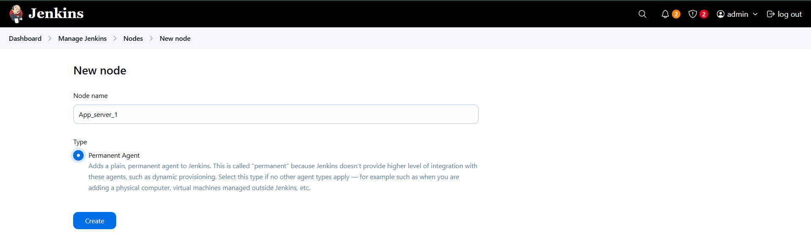
- Configure the node:
  - Remote root directory: /home/tony/jenkins
  - Labels: App_server_1 : stapp01
  - Usage: Only build jobs with label expressions matching this node
  - Launch method: Launch agents via SSH
  - Host: stapp01
  - Credentials: tony
  - Host Key Verification Strategy: Manually trusted
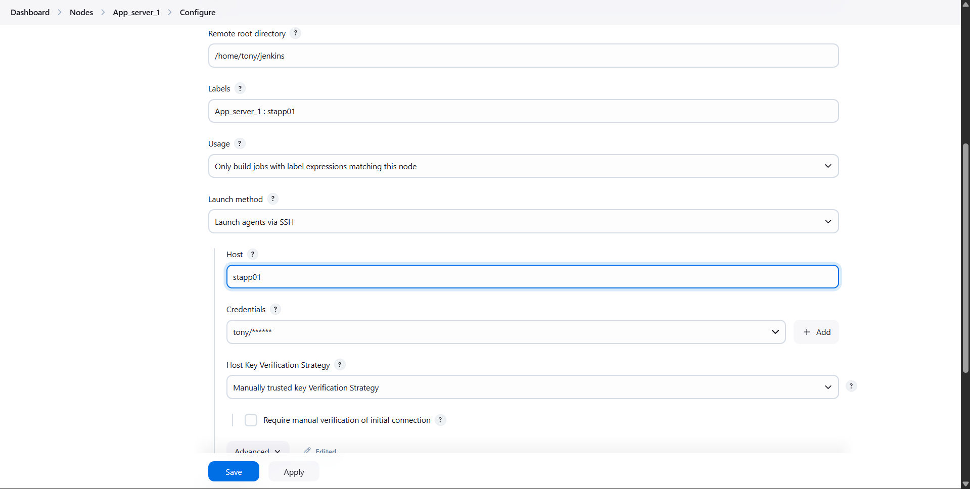
- Save the configuration.

Step 6: Create Jenkins Node – App_server_2
- Create a new node with the following details:
  - Node name: App_server_2
  - Type: Permanent Agent
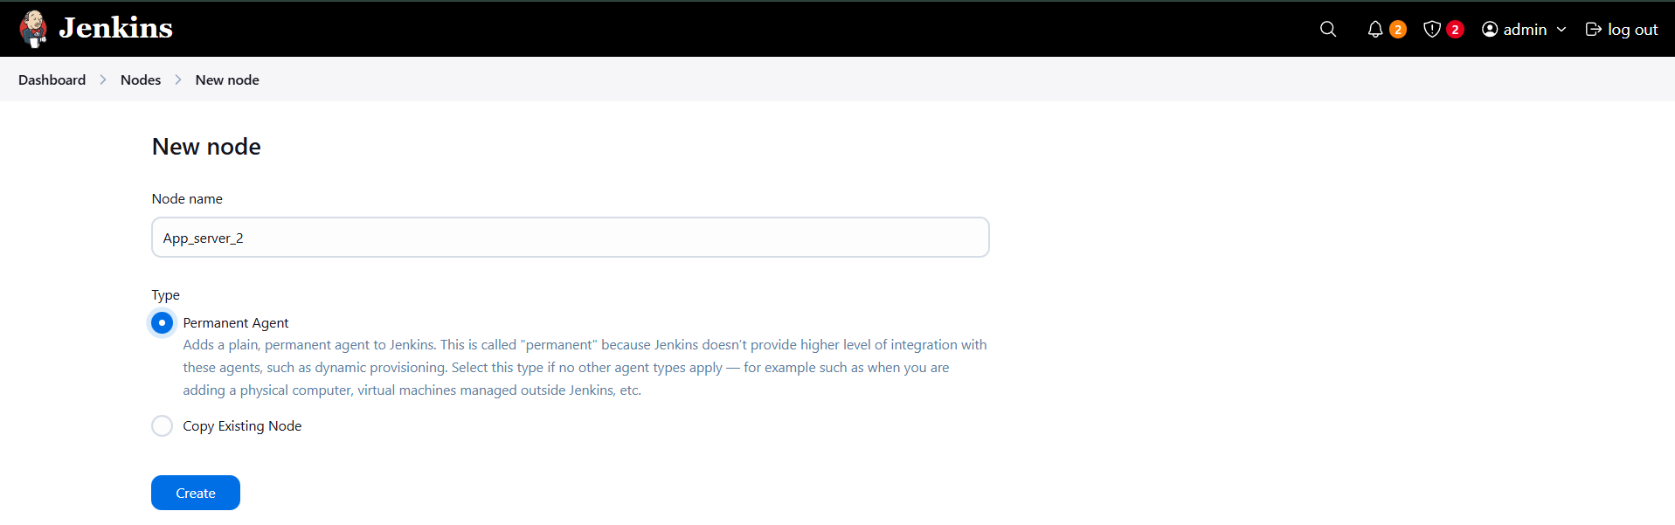
  - Remote root directory: /home/steve/jenkins
  - Labels: App_server_2 : stapp02
  - Usage: Only build jobs with label expressions matching this node
  - Launch method: Launch agents via SSH
  - Host: stapp02
  - Credentials: steve
  - Host Key Verification Strategy: Manually trusted
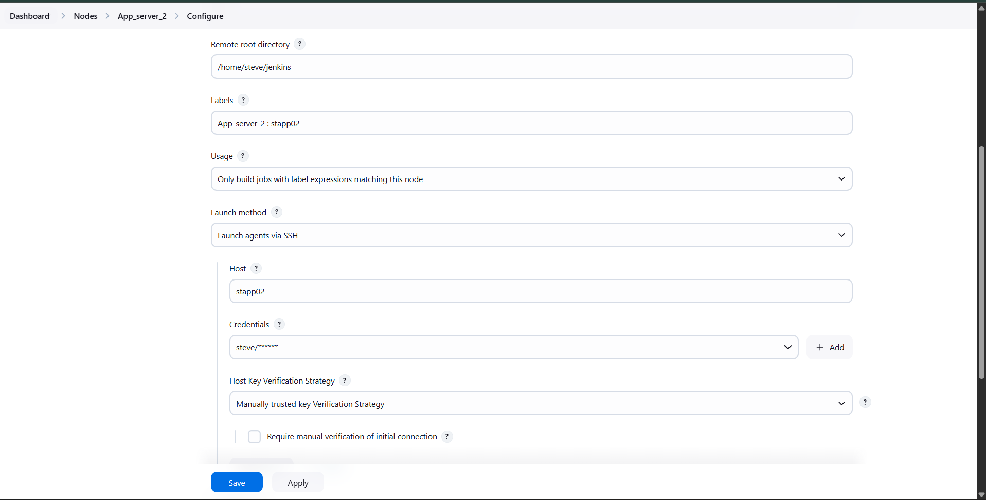
- Save the configuration.

Step 7: Create Jenkins Node – App_server_3
- Create a new node with the following details:
  - Node name: App_server_3
  - Type: Permanent Agent
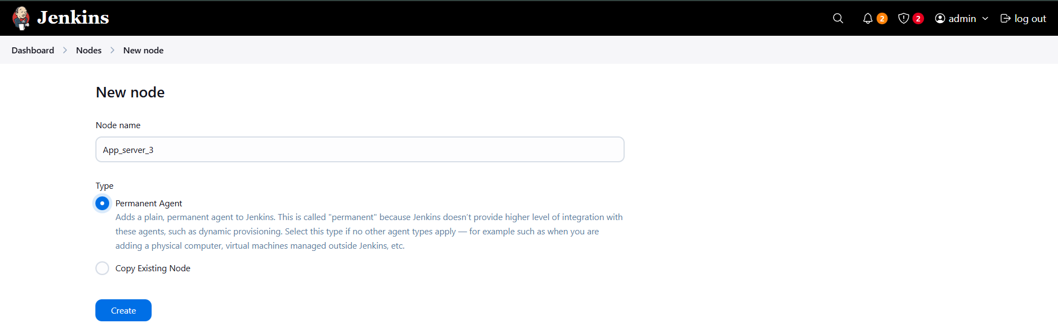
  - Remote root directory: /home/banner/jenkins
  - Labels: App_server_3 : stapp03
  - Usage: Only build jobs with label expressions matching this node
  - Launch method: Launch agents via SSH
  - Host: stapp03
  - Credentials: banner
  - Host Key Verification Strategy: Manually trusted
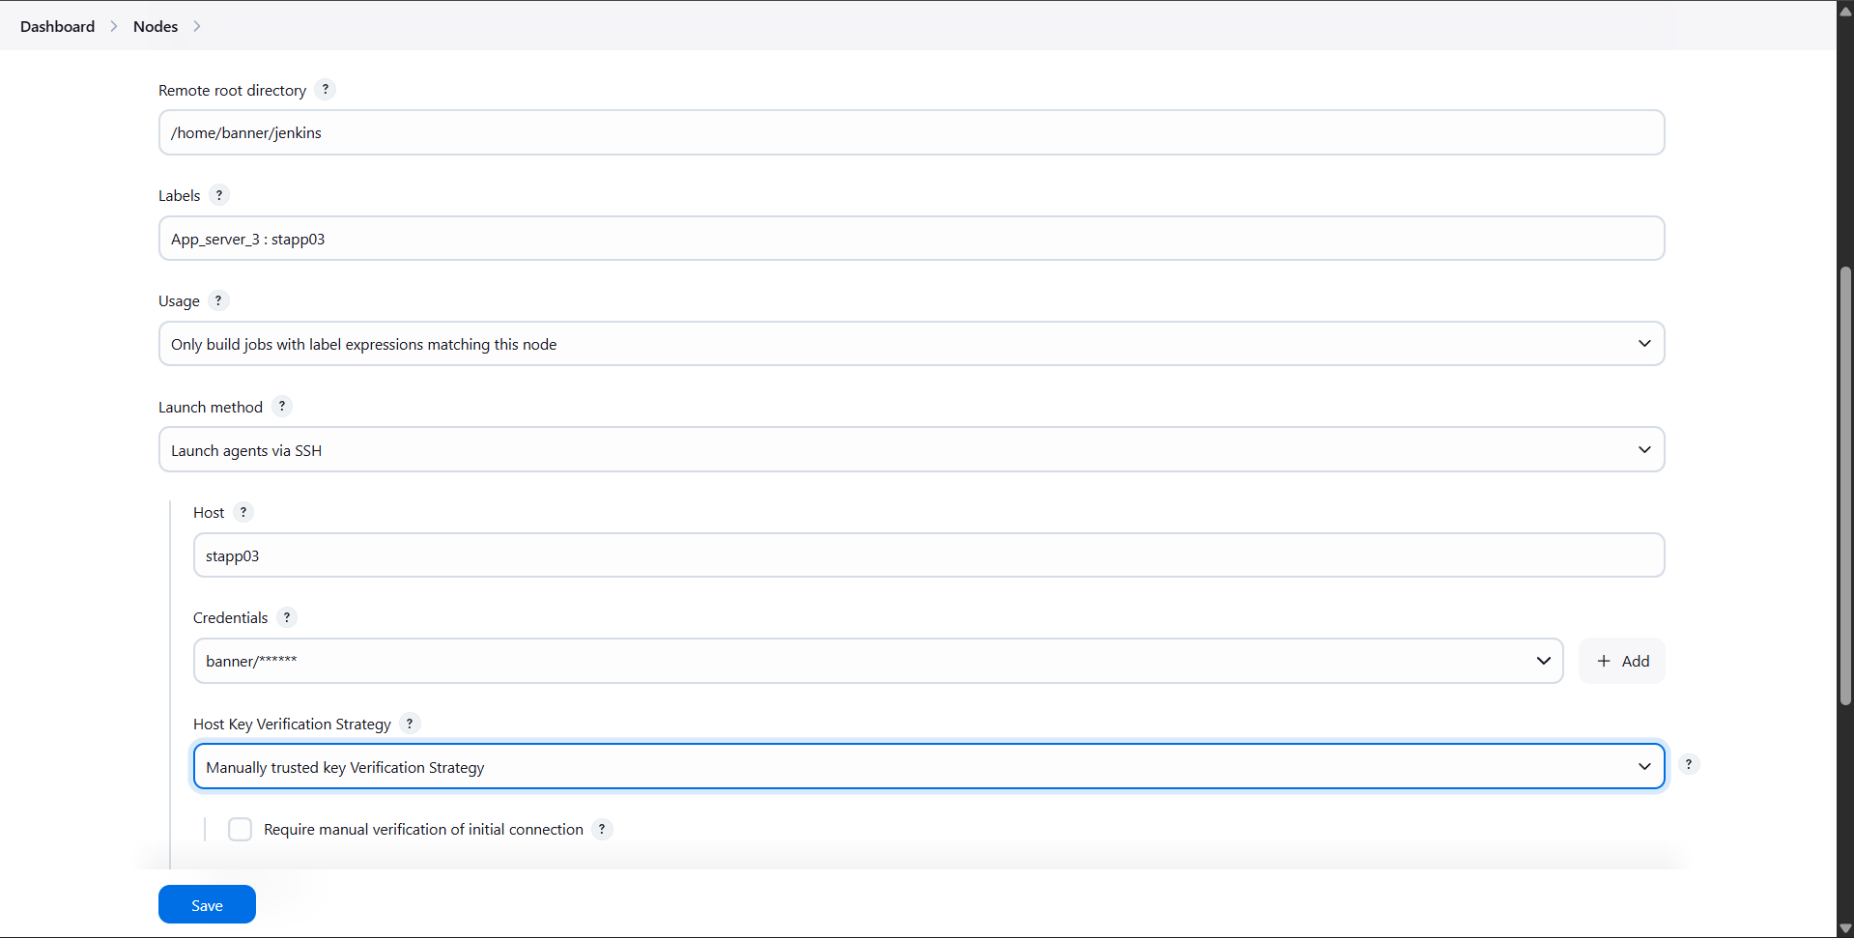
- Save the configuration.

Step 8: Verify Node Connectivity
- Navigate to Manage Jenkins → Nodes
- Ensure all nodes:
  - Are online
  - Show system details (disk space, response time)
  - Successfully connect via SSH

Step 9: Final Validation
- Confirm Jenkins agents are ready to accept builds.
- Verify labels can be used in Jenkins jobs for targeted execution.

